International Journal of Conference Proceedings | e-ISSN: 0000-0000 |2025,1(1):1-5.

SCIRO

Journal Home page: https://journals.sciro.org/index.php/ijbms
https://doie.org/10.97248/IJBMS.2025911169
XXXXXXXXXxXXXXXXXXXXXXXXXXXXXXXXXXXXXX
XXXXXXXXXXXXXXXXXXXXXXXXXXXXXXXXXXXXXXX
Dr. xxxxxx¹, Dr. xxxxxxx²
¹xxxxx (P.G), Andhra Loyola College (Autonomous), Vijayawada, NTR District-520008,
²Lxxxx, BVRIT Hyderabad College of Engineering for Women, Rajiv Gandhi Nagar, Nizampet Road, Bachupally, Hyderabad-500090.
Corresponding Author Email: xxxxx@gmail.com (T. Rojaramani)
Received: 03.09.2025 | Revised: 26.09.2025 | Accepted: 07.10.2025

Abstract: A library is a well-organized collection of information and resources, designed to serve a specific community by providing access for reading and research. The library is the hub of all academic activities and serves as a foundation for intellectual excellence. Effective utilization of library information resources contributes significantly to improving the literacy rate in India. Furthermore, the integration of technology has transformed the functioning of libraries, particularly through the development of e-information services. Library resources are highly useful for teaching, learning, research, updating knowledge, developing skills, and fostering personal growth. These resources consist of materials and information acquired by libraries to fulfill the informational needs of their users. The primary aim of this study is to examine students’ awareness, perceptions and usage practices related to library resources. Data for the study was gathered from both primary and secondary sources. Primary data was collected through a google form questionnaire completed by 223 respondents selected using the convenience sampling method. The sample respondents in this study consist of intermediate and graduate students.
Keywords: Students, Library services, Awareness and Perception.

INTRODUCTION
"But I must explain to you how all this mistaken idea of denouncing pleasure and praising pain was born and I will give you a complete account of the system, and expound the actual teachings of the great explorer of the truth, the master-builder of human happiness. No one rejects, dislikes, or avoids pleasure itself, because it is pleasure, but because those who do not know how to pursue pleasure rationally encounter consequences that are extremely painful. Nor again is there anyone who loves or pursues or desires to obtain pain of itself, because it is pain, but because occasionally circumstances occur in which toil and pain can procure him some great pleasure. To take a trivial example, which of us ever undertakes laborious physical exercise, except to obtain some advantage from it? But who has any right to find fault with a man who chooses to enjoy a pleasure that has no annoying consequences, or one who avoids a pain that produces no resultant pleasure?"
REVIEW OF LITERATURE
"But I must explain to you how all this mistaken idea of denouncing pleasure and praising pain was born and I will give you a complete account of the system, and expound the actual teachings of the great explorer of the truth, the master-builder of human happiness. No one rejects, dislikes, or avoids pleasure itself, because it is pleasure, but because those who do not know how to pursue pleasure rationally encounter consequences that are extremely painful. Nor again is there anyone who loves or pursues or desires to obtain pain of itself, because it is pain, but because occasionally circumstances occur in which toil and pain can procure him some great pleasure. To take a trivial example, which of us ever undertakes laborious physical exercise, except to obtain some advantage from it? But who has any right to find fault with a man who chooses to enjoy a pleasure that has no annoying consequences, or one who avoids a pain that produces no resultant pleasure?"
METHODOLOGY
"But I must explain to you how all this mistaken idea of denouncing pleasure and praising pain was born and I will give you a complete account of the system, and expound the actual teachings of the great explorer of the truth, the master-builder of human happiness. No one rejects, dislikes, or avoids pleasure itself, because it is pleasure, but because those who do not know how to pursue pleasure rationally encounter consequences that are extremely painful. Nor again is there anyone who loves or pursues or desires to obtain pain of itself, because it is pain, but because occasionally circumstances occur in which toil and pain can procure him some great pleasure. To take a trivial example, which of us ever undertakes laborious physical exercise, except to obtain some advantage from it? But who has any right to find fault with a man who chooses to enjoy a pleasure that has no annoying consequences, or one who avoids a pain that produces no resultant pleasure?"
Figure-1
Student perception towards library services 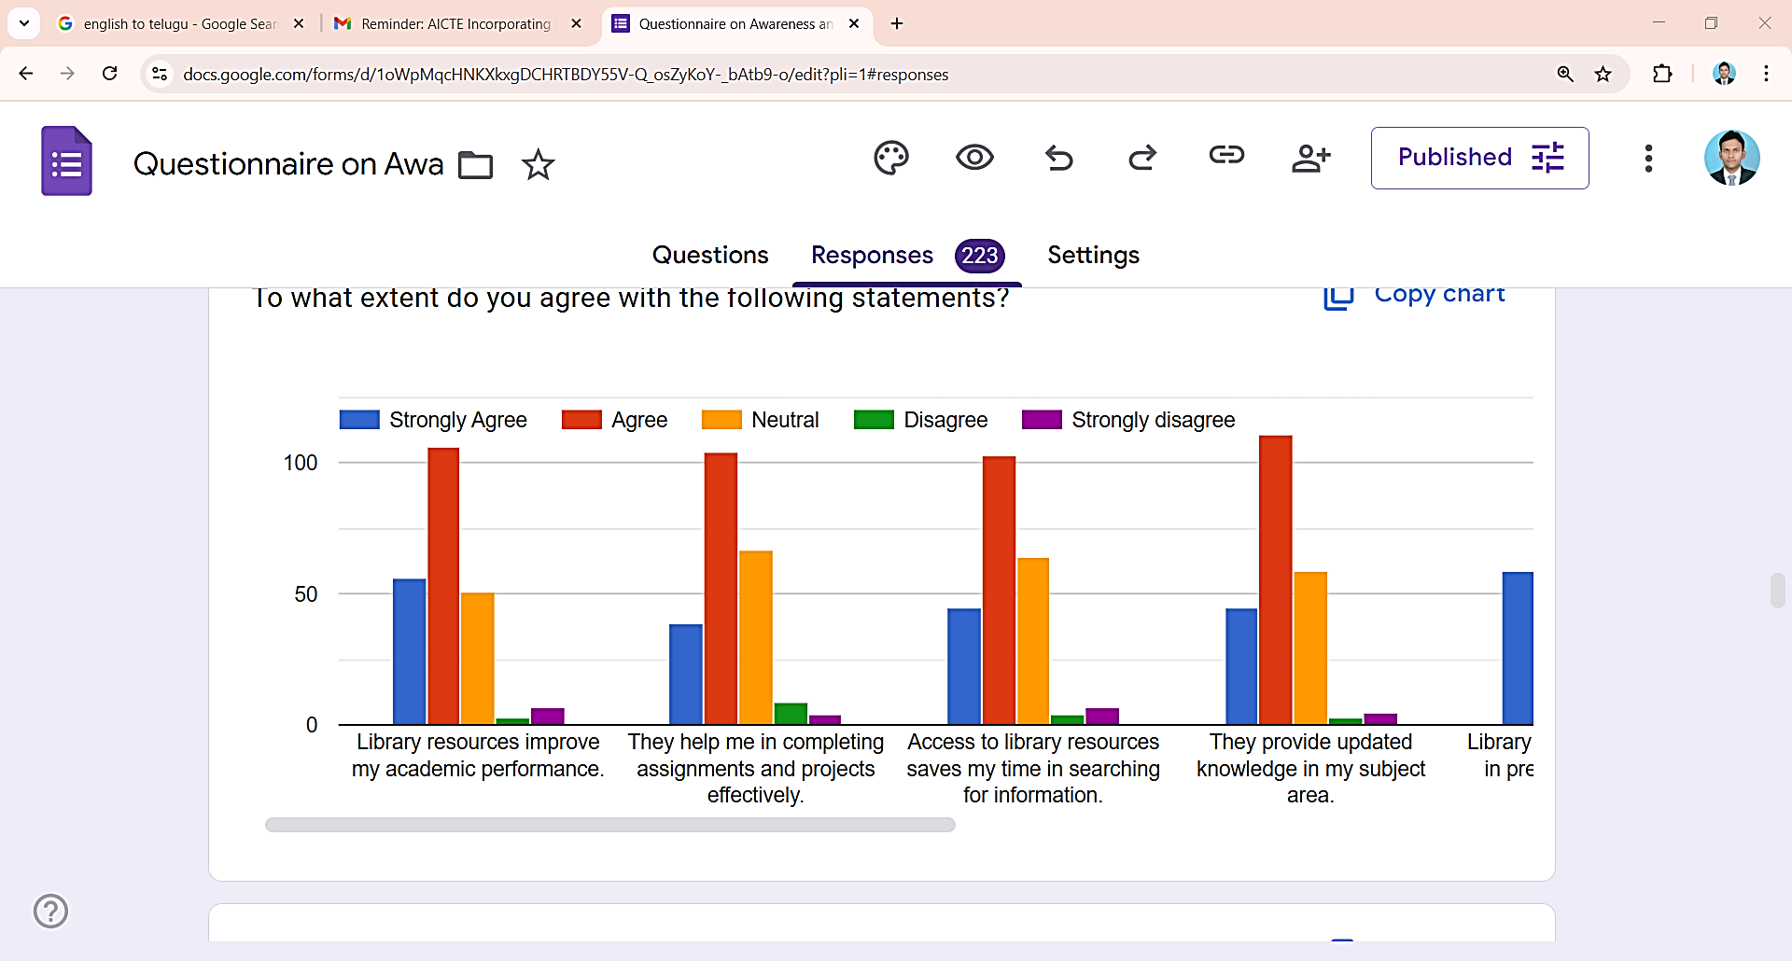
Source: Primary data.
IMPLEMENTATION
"But I must explain to you how all this mistaken idea of denouncing pleasure and praising pain was born and I will give you a complete account of the system, and expound the actual teachings of the great explorer of the truth, the master-builder of human happiness. No one rejects, dislikes, or avoids pleasure itself, because it is pleasure, but because those who do not know how to pursue pleasure rationally encounter consequences that are extremely painful. Nor again is there anyone who loves or pursues or desires to obtain pain of itself, because it is pain, but because occasionally circumstances occur in which toil and pain can procure him some great pleasure. To take a trivial example, which of us ever undertakes laborious physical exercise, except to obtain some advantage from it? But who has any right to find fault with a man who chooses to enjoy a pleasure that has no annoying consequences, or one who avoids a pain that produces no resultant pleasure?"
Table - 5
How long do students usually spend in the library during each visit
How long do students usually spend in the library during each visit | No. of the Sample Respondents | In %
Less than 1 hour | 63 | 28.3
1–2 hours | 142 | 63.7
2–3 hours | 13 | 5.8
More than 3 hours | 05 | 2.2
Total | 223 | 100
Source: Primary data.
RESULT ANALYSIS
"But I must explain to you how all this mistaken idea of denouncing pleasure and praising pain was born and I will give you a complete account of the system, and expound the actual teachings of the great explorer of the truth, the master-builder of human happiness. No one rejects, dislikes, or avoids pleasure itself, because it is pleasure, but because those who do not know how to pursue pleasure rationally encounter consequences that are extremely painful. Nor again is there anyone who loves or pursues or desires to obtain pain of itself, because it is pain, but because occasionally circumstances occur in which toil and pain can procure him some great pleasure. To take a trivial example, which of us ever undertakes laborious physical exercise, except to obtain some advantage from it? But who has any right to find fault with a man who chooses to enjoy a pleasure that has no annoying consequences, or one who avoids a pain that produces no resultant pleasure?"
CONCLUSION
"But I must explain to you how all this mistaken idea of denouncing pleasure and praising pain was born and I will give you a complete account of the system, and expound the actual teachings of the great explorer of the truth, the master-builder of human happiness. No one rejects, dislikes, or avoids pleasure itself, because it is pleasure, but because those who do not know how to pursue pleasure rationally encounter consequences that are extremely painful. Nor again is there anyone who loves or pursues or desires to obtain pain of itself, because it is pain, but because occasionally circumstances occur in which toil and pain can procure him some great pleasure. To take a trivial example, which of us ever undertakes laborious physical exercise, except to obtain some advantage from it? But who has any right to find fault with a man who chooses to enjoy a pleasure that has no annoying consequences, or one who avoids a pain that produces no resultant pleasure?"
FUTURE SCOPE
"But I must explain to you how all this mistaken idea of denouncing pleasure and praising pain was born and I will give you a complete account of the system, and expound the actual teachings of the great explorer of the truth, the master-builder of human happiness. No one rejects, dislikes, or avoids pleasure itself, because it is pleasure, but because those who do not know how to pursue pleasure rationally encounter consequences that are extremely painful. Nor again is there anyone who loves or pursues or desires to obtain pain of itself, because it is pain, but because occasionally circumstances occur in which toil and pain can procure him some great pleasure. To take a trivial example, which of us ever undertakes laborious physical exercise, except to obtain some advantage from it? But who has any right to find fault with a man who chooses to enjoy a pleasure that has no annoying consequences, or one who avoids a pain that produces no resultant pleasure?"
REFERENCES
Somtochukwu Sunday Ugochukwu (2025) Awareness and Utilization of Library Resources in Samuel Osaigbovo Ogbemudia Library, DOI: 10.13140/RG.2.2.30306.64969.
Vijaykumar N & Roopa G (2024) Awareness and Use of Library Resource and Services in Babasaheb Dr. B. R. Ambedkar Central Library, Bangalore University: A Study, International Journal of Creative Research Thoughts (IJCRT), Volume 12, Issue 7, ISSN: 2320-2882.
Panduranga Swamy Matta & B. Prasada Rao (2023) Awareness and Utilization of Library Resources and Services by the Students of Sri Sathya Sai Institute of Higher Learning, Anantapur Campus - A Study, Library Philosophy and Practice (e-journal), University of Nebraska – Lincoln.
Banda Boniface (2023) Off-Campus Students and their Challenges: A Case of University of Zambia Library, International Journal of Library and Information Studies, Vol.13(2), ISSN: 2231-4911.
Rajasekaran S, Pandeeswaran C, P. Selvakamal, & M. Ganesamoorthy (2023) Digital Library Services and its Utilization Among the Students: A Case Study, Journal of Information Technology and Sciences, Volume-9, Issue-1, Page 30-35, e-ISSN: 2581-849X.
Onwubiko Emmanuel Chidiadi (2022) Awareness and Utilization of Scholarly e-Resources by Student-librarians: Implication for the Realization of the UN Sustainable Development Goal, International Journal of Information and Communication Sciences, Vol. 7, No. 1, 2022, pp. 1-9, ISSN: 2575-1700 (Print); ISSN: 2575-1719 (Online).
Sushma, H R & Ramesha (2022) Awareness and Use of Web Resources and Services Among the Faculty Members and Researchers of Bangalore University: A Study, Journal of Indian Library Association, Vol, 58(4).
Kokkula Surendher (2022) Technology Enabled Library Services, International Journal of Creative Research Thoughts (IJCRT), Volume 10, Issue 10, ISSN: 2320-2882.
Ebaye, A. S. & Osim, T. A (2022) Utilization of Information Resources and Services among Undergraduate Students in Federal University Libraries in South-South, Nigeria, Texila International Journal of Academic Research, ISSN: 2520-3088.
Nesba Yaa Anima Adzobu Armah & Mac-Anthony Cobblah (2021) An Assessment of the Multiple Challenges Associated with Student’s Access to Electronic Resources at a Public University Library in Ghana, International Journal of Knowledge Content Development & Technology, Vol.11, No.1, 65-84.
Sukla Chakrabortya and Siladitya Janab (2021) Challenges and opportunities of academic libraries in India because of Covid-19, Annals of Library and Information Studies, Vol. 68, pp. 110-118.
Booysen Sabeho Tubulingane (2021) University Library Services and Student Academic Performance, International Journal of Library and Information Services, Volume 10, Issue 2.
Prema Jayaraj & Kannappanavar B. U. (2021) Awareness and Utilization of Library Resources and Services by M. Com Students and Faculty Members in College Libraries of Udupi District: A Case Study, Library and Information Science Commons, University of Nebraska Lincoln, Library Philosophy and Practice (e-journal).
Danlami Abdullahi, Aliyu Isyaku Ahmad (CLN) and Umar Ahmed (2019) Awareness and Utilization of Library Resources in Bauchi State College of Agriculture Library, African Journal of Social Sciences and Humanities Research, Volume 2, Issue 3, pp. 38-46.
Fasa Rachael Aladeniyi and Temitope Samuel Owokole (2018) Utilization of Library Information Resources by Undergraduate Students of University of Medical Science Ondo, Ondo State, Nigeria, American International Journal of Contemporary Research, Vol. 8, No. 4, ISSN 2162-139X (Print), 2162-142X (Online).

